Maini Precisions – AWS CloudFormation Service Delivery Case Study
2025
AWS Support Document
Document version: 1.0
Aeonx digital technology pvt. ltd.
About the Customer
Maini is an end-to-end solutions provider engaged in process design, engineering, manufacturing, testing, and supply of a variety of precision products and assemblies. They have a diversified business, wherein their products are classified into two business, being (a) aerospace, which comprises precision products manufactured for aerospace and defence, and (b) automotive and industrial, which comprises precision products manufactured for clean internal combustion engines, fuel injections and transmissions (internal combustion engines, fuel injections and transmissions collectively referred to as “Clean Powertrain”), hydraulics and industrial, agriculture and legacy automotive.
Their diverse capabilities allow them to service customers globally. Their products are used across various industries such as aerospace, defence, automotive Clean Powertrain, power tools, material handling, hydraulic, marine, locomotive, and electronics.
They have 11 manufacturing facilities, which are located in Bangalore, India. Their various manufacturing facilities have been duly certified in accordance with international standards of quality management systems, environmental management systems, health and safety management systems and specialized processes, including IATF - 16949, AS 9100 Rev. D, NADCAP certificate for Non-destructive Testing (“NDT”) and welding, ISO 14001, and ISO 45001.

Customer Challenges
Maini Precision Products Limited, a leader in precision manufacturing, faced operational inefficiencies stemming from both business and technical limitations in leveraging shop-floor machine data.

Business Challenges
- Manual, Fragmented Deployments: Legacy applications for supply chain operations suffered from error-prone manual deployments, resulting in slower releases and operational bottlenecks.
- Complex Supply Chain: Onboarding new vendors, handling fluctuating order volumes, and meeting just-in-time manufacturing demands required greater automation and scalability.
- Security Expectations: Growing pressure to safeguard sensitive business and supply chain data with strong access controls and compliance measures.

Technical Challenges
- Inconsistent Infrastructure: Manual configuration resulted in inconsistencies across application stacks, increasing risk of deployment failures, service outages, and troubleshooting complexity.
- Limited Monitoring & Recovery: Inadequate centralized monitoring and the absence of automated backups hampered issue detection, alerting, and disaster recovery preparedness.
- Scalability Bottlenecks: The existing setup struggled to scale resources dynamically, making it difficult to respond efficiently to changes in business demand.

Risks and Impact if the Challenge Were Not Addressed
- Operational Downtime: Interruptions to critical supply chain applications could halt manufacturing and delivery, impacting revenue and customer satisfaction.
- Security Breaches or Compliance Gaps: Inconsistent security controls and lack of audit trails could expose proprietary or customer data.
- Competitive Disadvantage: Slow-release cycles and operational inefficiencies would erode Maini’s ability to innovate and respond to market changes.

About the Partner
AeonX Digital is an AWS Managed Service Partner noted for its expertise in designing, building, and managing automated, cloud-first infrastructures for industrial and manufacturing clients. AeonX delivers robust, secure, and fully managed AWS environments with a strong focus on automation, scalability, and compliance through Infrastructure as Code best practices.

Solution Provided
AeonX Digital architected and delivered a secure, resilient, and automated AWS environment for three core supply chain applications—Supplier Portal, Tools Pulse, and Gauge Caliber—using AWS CloudFormation as Infrastructure as Code (IaC). Key aspects include:
- Modular IaC: All networks (VPC, subnets, route tables, gateways), compute (EC2 in Auto Scaling Groups), storage (S3), databases (Amazon RDS), security (WAF, IAM, KMS), and monitoring and logging (CloudWatch, CloudTrail, SNS) resources are defined and managed via parameterized CloudFormation templates.
- Automated CI/CD: Application code is versioned in GitHub and deployed through pipelines orchestrated by AWS CodePipeline, CodeBuild, and CodeDeploy, with static code analysis (SonarQube) and security checks (Snyk) enforcing quality as part of the release process.
- Resilient Data Layer: Amazon RDS is deployed in private subnets with automated backups and encryption; there is no multi-AZ configuration, but regular snapshots support disaster recovery.
- Layered Security: AWS WAF and CloudFront safeguard the application edge, IAM manages user/service access, traffic is isolated with security groups, and secrets are stored securely with AWS Secrets Manager.

Functional Workflow
- User Access: External users access applications via custom domains managed by Route 53. Requests are served through Amazon CloudFront, with AWS WAF providing threat protection at the edge.
- Traffic Routing: CloudFront distributes and optimizes incoming requests, forwarding approved traffic to the Application Load Balancer (ALB) in the public subnet.
- Application Functionality: The ALB directs sessions to backend EC2 instances (deployed via Auto Scaling Groups) hosted in private subnets. Each core application—Supplier Portal, Tools Pulse, Gauge Caliber—operates as an isolated backend service.
- Data Operations: Application backends interact with Amazon RDS (in private subnet, single AZ) for transactional data and with Amazon S3 for storing and retrieving static assets and documents.
- Continuous Integration & Deployment: Code changes committed in GitHub initiate automated build and test processes (CodeBuild, SonarQube, Snyk checks), followed by staged deployments via CodeDeploy, ensuring quality and security at every stage.
- Monitoring & Backup: CloudWatch monitors resource utilization, logs events/metrics, and triggers alarms. CloudTrail audits all changes. AWS Backup schedules regular RDS and EC2 backups for disaster recovery.
- Security Enforcement: IAM gives precise role-based access to users and services; KMS encrypts data at rest; AWS Secrets Manager securely stores credentials for applications and databases.

Architecture Diagram
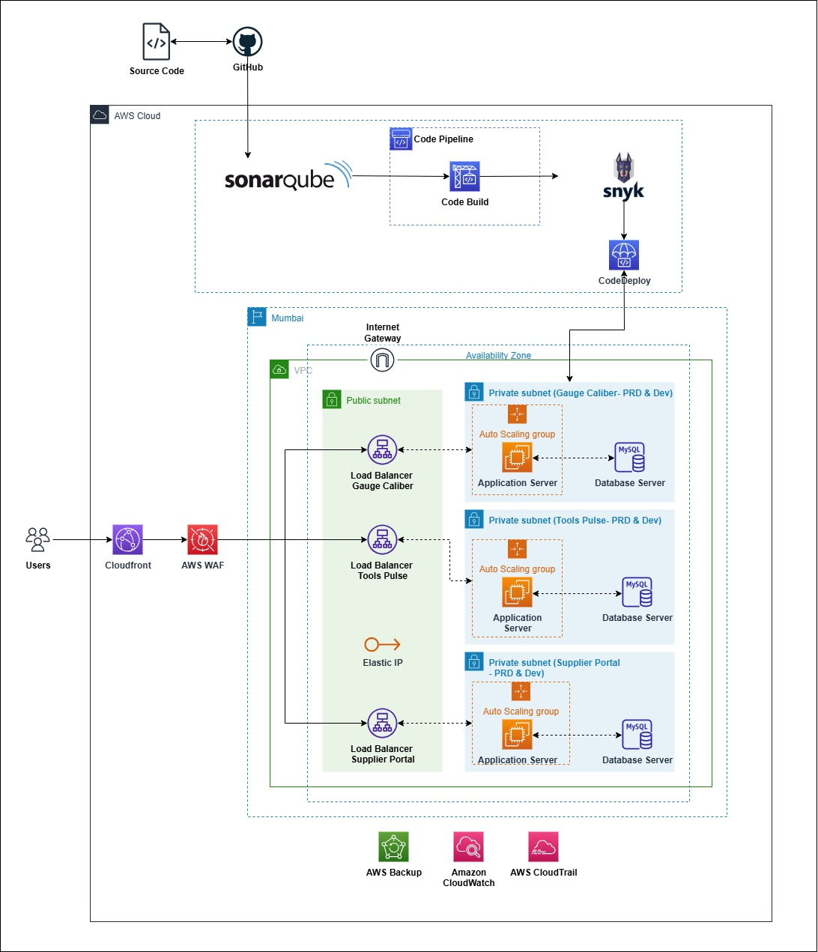

- Networking Layer:
  - Custom Amazon VPC, with segmentation into public subnets (for ALB, NAT Gateway) and private subnets (for application EC2, RDS).
  - Public subnets host the ALB, exposing only necessary endpoints to the internet.
  - NAT Gateway allows application servers in private subnets to access external resources securely.
- Compute & Application Layer:
  - Supply chain app workloads run on EC2 instances managed by Auto Scaling Groups, which dynamically adjust resources with workload changes.
  - All compute resources are isolated in private subnets.
- Load Balancing & Application Edge:
  - Application Load Balancer provides health checks, SSL termination, application-layer routing, and blue/green or rolling deployment support.
  - Amazon CloudFront distributes content globally and integrates with AWS WAF for advanced security filtering.
- Data Layer:
  - Amazon RDS provides managed MySQL databases, deployed in private subnets with automated scheduled backups but without multi-AZ failover.
- Security & Compliance:
  - AWS WAF filters traffic, IAM restricts access, KMS encrypted storage, and Secrets Manager for sensitive secrets/certificates.
- Automation & Monitoring:
  - CloudFormation orchestrates resource creation and updates.
  - CloudTrail audits all resource changes.
  - CloudWatch and AWS Backup provide centralized monitoring and recovery.

Results and Benefits
Area | Achievement
Deployment Speed | Automated builds and infrastructure provisioning cut release cycles by over 50%.
Scalability & Availability | Modular architecture with ALB, CloudFront, and auto scaling supports business growth and strong uptime.
Security & Compliance | VPC, WAF, IAM, and KMS-backed encryption minimized risk and supported robust compliance.
Operational Efficiency | Infrastructure as Code reduced manual effort, streamlined updates, and minimized errors.
Business Continuity | CloudWatch-based monitoring and regular automated backups provided reliable disaster recovery and rapid fault detection.

Conclusion
AeonX Digital transformed Maini Precisions’ supply chain operations from manual, error-prone deployments to a modern, cloud-native platform. The AWS-based solution harnesses advanced automation, security, and resilience without multi-AZ or explicit environment segregation. This has enabled faster feature releases, improved KPI uptime, and empowered Maini to support evolving supply chain and business needs with confidence and agility.

