Ashapura Minechem – AWS CloudFormation Service Delivery Case Study
2025
AWS Support Document
Document version: 1.0
Aeonx digital technology pvt. ltd.
About the Customer
With a legacy of more than 60 years, Ashapura is a leading multi-mineral solutions provider with a global footprint, having a wide network of operations in several states within India and in other countries.
Their captive mineral resources, state-of-the-art manufacturing base, cutting edge research capabilities, logistical prowess and 2,800 dynamic, progressive, result oriented employees accord us global leadership in several segments. Their consistent quality and their ability to customize mineral solutions make them a preferred supplier to multi-nationals in more than 70 countries across the continents.
Ashapura means “Fulfilling Aspirations”; they believe that sustainable growth occurs only when they fulfil aspirations of all their stakeholders such as customers, employees, shareholders, the environment and the society as a whole.
Customer Challenges
With rapid business expansion, Ashapura faced significant barriers maintaining and scaling their CRM and Employee Portal platforms, which are critical for customer management, HR workflows, and employee engagement.
Business Challenges
- Siloed Legacy Applications: CRM and Employee Portal ran on fragmented, on-premises infrastructure, resulting in duplicated data and inconsistent workflows.
- Manual Processes: Deployments and environment changes required hands-on intervention, leading to delays, higher error rates, and reduced productivity.
- Global Access Demand: As a multinational, Ashapura required secure, reliable 24/7 application availability for employees and partners worldwide.
- Data Security & Compliance: Handling sensitive customer and HR data meant increased demands on security, auditability, and regulatory alignment.
Technical Challenges
- Environment Consistency: Manual provisioning and configuration led to inconsistent infrastructure setups, increasing the risk of deployment failures and outages.
- Monitoring & Recovery: Insufficient centralized monitoring and lack of automated backups hindered rapid issue detection, troubleshooting, and disaster recovery.
- Scalability Bottlenecks: Legacy infrastructure lacked flexibility to dynamically scale resources, making it difficult to efficiently handle growth and varying workloads.
Risks and Impact if the Challenge Were Not Addressed
Failure to modernize and optimize Ashapura’s logistics operations would have led to significant business and technical setbacks, affecting scalability, profitability, and customer experience.
- Downtime: Increases the risk of business interruption impacting customer service and employee productivity.
- Data Breach/Compliance Issues: Potential exposure of sensitive data due to inconsistent security measures.
- Inefficiency: Prolonged manual operations would limit digital transformation and competitiveness.
About the Partner
AeonX Digital is an AWS Managed Service Partner renowned for its expertise in cloud transformation projects across manufacturing, mining, and industrial sectors. AeonX delivers secure, resilient, and scalable cloud solutions—leveraging AWS CloudFormation and native AWS services for automation, compliance, and long-term agility.
Solution Provided
AeonX Digital architected and delivered a modern, secure AWS environment for the CRM and Employee Portal, leveraging:
- AWS CloudFormation: Infrastructure as Code for consistent, repeatable provisioning of networks, compute, databases, security, and monitoring.
- AWS-Native CI/CD Pipeline: Automated software delivery with GitHub, AWS CodePipeline, CodeBuild, and CodeDeploy.
- Security Controls: Strict IAM practices, KMS-driven encryption, private/public subnet isolation, and application protection using AWS WAF and CloudFront.
- Data Management: Amazon RDS for managed, encrypted database services and S3 for scalable storage.
- Observability & Recovery: Amazon CloudWatch and CloudTrail for monitoring and audit, AWS Backup for automated backups.
Functional Workflow
- User Access & Routing:
  - Employees or customers resolve application URLs using Route 53 DNS.
  - Requests are served through CloudFront, which caches static content for speed and forwards dynamic requests to the ALB.
- Web Application Protection:
  - Every incoming request is inspected by AWS WAF, blocking threats before they reach the app servers.
- Load Balancing & Distribution:
  - ALB distributes legitimate traffic across healthy application servers in private subnets, ensuring redundancy and scaling based on current load.
- Application Processing:
  - EC2 app servers authenticate users (often via IAM or a managed authentication provider) and process business logic for CRM or Employee Portal operations.
  - Application servers interact with Amazon RDS for persistent data storage and retrieve/store files to S3 as needed.
- Continuous Deployment:
  - Developers commit code to GitHub.
  - CI/CD pipeline (AWS CodePipeline → CodeBuild → CodeDeploy) automates build, test, and deployment steps, ensuring fast, reliable releases.
- Security & Credentials:
  - Application code retrieves secrets (e.g., DB passwords) securely from AWS Secrets Manager.
  - All sensitive data is encrypted at rest (KMS) and in transit (TLS via CloudFront/ALB).
- Monitoring & Operations:
  - CloudWatch collects real-time logs and metrics from all components.
  - Alarms and dashboards notify operations of issues, enabling rapid troubleshooting.
  - CloudTrail records all infrastructure and user activity for audits.
- Backup and Recovery:
  - Automatic backups of RDS and EC2 are managed by AWS Backup.
  - In the event of a failure, systems can restore from backup with minimal downtime.
Architecture Diagram:
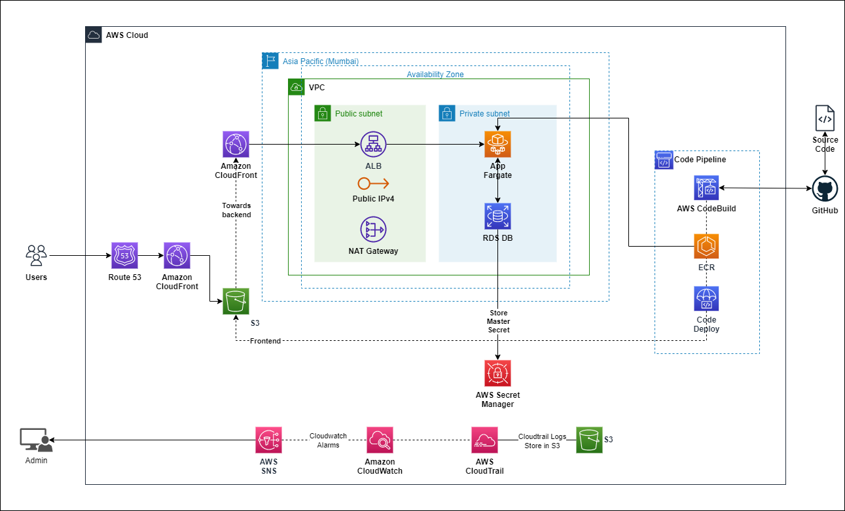

1. Networking & Security
- Amazon VPC: A logically isolated network with both public and private subnets spread across multiple Availability Zones for high availability and fault tolerance.
- Subnets:
  - Public Subnets: Host the Application Load Balancer (ALB) and NAT Gateway.
  - Private Subnets: Host backend application servers (EC2 instances or ECS services) and databases, unreachable directly from the Internet.
- Internet Gateway & NAT Gateway: The Internet Gateway provides inbound and outbound internet connectivity for resources in public subnets. The NAT Gateway allows instances in private subnets to initiate outbound connections while blocking unsolicited inbound traffic, maintaining security.
- Route Tables: Customized to control traffic flow between public and private subnets, ensuring only allowed communications.
- AWS Security Groups & NACLs: Act as virtual firewalls, strictly controlling which ports and addresses can communicate between tiers and with the outside world.
- DNS with Route 53: Provides domain name resolution for rapid, reliable user access globally.
2. Application Access and Protection
- AWS CloudFront: Sits in front of the ALB, caching static content (from S3 or app) for global low-latency delivery, and terminating HTTPS at the edge.
- AWS WAF: Integrated with CloudFront and ALB to block malicious requests and common attack patterns (like SQL injection or XSS).
3. Application (Compute) Layer
- EC2 Instances (or ECS): Deployed within private subnets, hosting CRM and Employee Portal applications. Can auto-scale base on demand, ensuring performance and cost-efficiency.
- ALB (Application Load Balancer): Distributes incoming traffic from CloudFront to application servers, checks health, manages session stickiness, and terminates SSL if configured.
- IAM: Manages granular, least-privilege access for all compute instances, users, and services, tightly controlling permissions.
4. Data Layer
- Amazon RDS: Managed relational database (MySQL) deployed in multi-AZ mode for failover and continuous availability. Backups and snapshots are automatically taken per schedule.
- KMS Encryption: All database and S3 storage is encrypted at rest using customer-managed or AWS-managed keys.
- AWS Secrets Manager: Securely stores and rotates database and application credentials, accessed programmatically by application servers.
5. Storage & Backup
- Amazon S3: Used for storing static web assets, file uploads, user media, logs, and even periodic database backups.
- AWS Backup: Provides policy-based backup and restore for RDS and EC2 environments.
6. Monitoring, Logging, and Compliance
- CloudWatch: Aggregates logs/metrics from all tiers, triggers alarms for system anomalies, and drives dashboards for the operations team.
- CloudTrail: Audits every API activity and change, providing a tamper-proof record for compliance and investigation.
- SNS: Pushes alerts to operations staff (via email/SMS) based on CloudWatch Alarms.

Results and Benefits
Area | Achievement
Deployment Speed | Automated builds and environment provisioning cut release cycles by over 50%.
Scalability & Availability | Modular architecture with ALB and auto scaling supports seamless business growth and high uptime.
Security & Compliance | End-to-end encryption, private networking, and audit logging reduced risk and supported regulatory needs.
Operational Efficiency | IaC reduced manual work, speed onboarding, and improved error detection/resolution.
Business Continuity | Centralized monitoring and automated backups ensured rapid disaster recovery and resilience.

Conclusion
AeonX Digital’s AWS-native solution fundamentally transformed Ashapura Minechem’s CRM and Employee Portal from isolated, error-prone legacy systems into a unified, resilient, and scalable cloud platform. The adoption of automation, rigorous security, and best-practice architecture delivered faster releases, higher reliability, and a future-ready foundation—empowering Ashapura’s next phase of digital growth and global leadership.

